**AI- DRIVEN DISEASE MONITORING AND SUPPORT SYSTEM**

By

**SHREYA ROJI**

Roll No. 2232MCA0005

Register No. 67222200142 A PROJECT REPORT

Submitted to the

**FACULTY OF INFORMATION AND COMMUNICATION ENGINEERING**

*in partial fulfillment for the award of the degree of*

**MASTER OF COMPUTER APPLICATIONS**



**CENTRE FOR DISTANCE EDUCATION ANNA UNIVERSITY**

**CHENNAI – 600025**

**December 2024**

## BONAFIDE CERTIFICATE

Certified that the project report titled “AI-DRIVEN DISEASE MONITORING AND SUPPORT SYSTEM” is the bonafide work of **SHREYA ROJI** who carried out the work under my supervision. Certified further that to the best of my knowledge the work reported herein does not form part of any other project report or dissertation on the basis of which a degree or award was conferred on an earlier occasion on this or any other candidate.

Signature of Student

**Shreya Roji**

Roll No: 2232MCA0002

Register No: 67222200142

Signature of Guide

**Dr. Arockia Xavier Annie** Associate Professor CEG, Department of Computer

Science and Engineering, Anna University, Chennai-25

## CERTIFICATE OF VIVA-VOCE EXAMINATION

This is to certify that **SHREYA ROJI** (**Roll No**: 2232MCA0005; **Register N**o: 67222200142) has been subjected to Viva-voce-Examination on............... at the Study Centre for Distance Education, Anna University**.**

**Internal Examiner External Examiner**

**Name : Name :**

**Designation : Designation :**

**Address : Address :**

**Coordinator Study Centre**

## ACKNOWLEDGEMENT

First and foremost, I would like to Dr. AROCKIA XAVIER ANNIE**,** Associate Professor CEG, Department of Computer Science and Engineering, Anna University, Chennai for her constant motivation throughout the course.

I am most grateful to Mrs. N. SARASWATHI, Assistant Professor, Centre for Distance Education, Anna University, Chennai for his guidance and constant supervision as well as for providing necessary information throughout the completion of this project. I also thank my review committee member Dr. S. PRADEEP, Assistant Professor, Centre for Distance Education, Anna University, Chennai for her moral support.

I am also grateful to my parents, friends and colleagues for their timely support and constant words of encouragement. Last but not the least; I extend my thanks to The Almighty.

**(SHREYA ROJI)**

# ABSTRACT

Artificial Intelligence (AI) has emerged as a transformative force across numerous industries, with healthcare being one of its most impactful applications. By leveraging AI, tasks traditionally performed by humans can be automated, reducing costs, improving efficiency, and expanding the reach of critical medical services. AI's ability to diagnose diseases in their early stages significantly enhances patient outcomes and facilitates healthcare delivery in remote and underserved areas. This project introduces WeCare, an AI-powered application that employs machine learning and deep learning algorithms to provide users with a reliable assessment of their risk for various critical diseases. The application focuses on six key health conditions: Liver Disease, Pneumonia, Kidney Disease, Diabetes, Stroke, and Heart Disease. The models used in WeCare are trained on extensive datasets to ensure high accuracy and reliability. In healthcare, AI's integration is particularly transformative, attracting major companies like Microsoft, Google, Apple, and IBM. AI not only streamlines processes for patients, doctors, and administrators but also delivers significant benefits. WeCare demonstrates the potential of AI in healthcare to democratize access to diagnostic tools, reduce the burden on healthcare systems, and empower individuals with actionable health insights. This report discusses the design, development, and implementation of WeCare, emphasizing its role in addressing global healthcare challenges.

செயற்கை நுண்ணறிவு (AI) பல சதொழில்ைளில் மொற்றும் ெை்தியொை உருசெடுத்Fள்ளF, சுைொதொரம் அதன் மிைவும் தொை்ைத்கத ஏற்படுத்Fம் பயன்பொடுைளில் ஒன்றொகும். AI ஐ மமம்படுத்Fெதன் மூலம், பொரம்பரியமொை மனிதர்ைளொல் செய்யப்படும் பணிைகள தொனியை்ைமொை்ைலொம், செலவுைகளை் குகறை்ைலொம், செயல்திறகன மமம்படுத்தலொம் மற்றும் முை்கியமொன மருத்Fெ மெகெைளின்

ெரம்கப விரிவுபடுத்தலொம். ஆரம்ப நிகலயிமலமய மநொய்ைகளை்

ைண்டறிெதற்ைொன AI இன் திறன் மநொயொளியின் விகளவுைகள

ைணிெமொை மமம்படுத்FகிறF மற்றும் சதொகலதூர மற்றும் பின்தங்கிய பகுதிைளில் சுைொதொர விநிமயொைத்கத எளிதொை்குகிறF.

இந்த திட்டம் WeCare ஐ அறிமுைப்படுத்FகிறF, இF AI-இயங்கும் பயன்பொடொகும், இF இயந்திர ைற்றல் மற்றும் ஆழமொன ைற்றல் அல்ைொரிதம்ைகளப் பயன்படுத்தி பயனர்ைளுை்கு பல்மெறு முை்கியமொன மநொய்ைளுை்ைொன அபொயத்கத நம்பைமொன மதிப்பீட்கட

ெழங்குகிறF. பயன்பொடு ஆறு முை்கிய சுைொதொர நிகலைளில் ைெனம் செலுத்FகிறF: ைல்லீரல் மநொய், நிமமொனியொ, சிறுநீரை மநொய், நீரிழிவு மநொய், பை்ைெொதம் மற்றும் இதய மநொய். WeCare இல் பயன்படுத்தப்படும் மொதிரிைள் அதிை Fல்லியம் மற்றும் நம்பைத்தன்கமகய உறுதிப்படுத்த விரிெொன தரவுத்சதொகுப்புைளில் பயிற்சியளிை்ைப்படுகின்றன. செல்த்மைரில், கமை்மரொெொப்ட், கூகுள், ஆப்பிள் மற்றும் ஐபிஎம் மபொன்ற சபரிய நிறுெனங்ைகள ஈர்ை்கும்

ெகையில், AI இன் ஒருங்கிகணப்பு குறிப்பொை உருமொறுகிறF. AI மநொயொளிைள், மருத்Fெர்ைள் மற்றும் நிர்ெொகிைளுை்ைொன செயல்முகறைகள சநறிப்படுத்FெF மட்டுமல்லொமல் குறிப்பிடத்தை்ை நன்கமைகளயும் ெழங்குகிறF. மநொயறிதல் ைருவிைளுை்ைொன அணுைகல ஜனநொயைப்படுத்தவும், சுைொதொர அகமப்புைளின் மீதொன சுகமகய குகறை்ைவும் மற்றும் செயல்படை்கூடிய சுைொதொர நுண்ணறிவுைளுடன் தனிநபர்ைளுை்கு அதிைொரம் அளிை்ைவும், சுைொதொரப் பொFைொப்பில் AI இன் திறகன WeCare நிரூபிை்கிறF. இந்த அறிை்கை WeCare இன் ெடிெகமப்பு, மமம்பொடு மற்றும் செயல்படுத்தல் பற்றி விெொதிை்கிறF, உலைளொவிய சுைொதொர ெெொல்ைகள எதிர்சைொள்ெதில் அதன் பங்கை ெலியுறுத்FகிறF.

**TABLE OF CONTENTS**

|  |  |  |
| --- | --- | --- |
| **CHAPTER NO.** | **TITLE** | **PAGE NO.** |
|  |  |  |
|  |  |  |
|  | **ABSTRACT** |  |
|  |  |  |
|  | **LIST OF FIGURES** |  |
|  |  |  |
| **1** | **INTRODUCTION** |  |
|  |  |  |
|  | 1.1 OVERVIEW OF THE PROJECT |  |
|  |  |  |
|  | 1.2 LITERATURE SURVEY |  |
|  |  |  |
|  | 1.3 PROPOSED SYSTEM |  |
|  |  |  |
|  | 1.4 OBJECTIVES AND SCOPE |  |
|  |  |  |
| **2** | **REQUIREMENTS AND SPECIFICATION** |  |
|  |  |  |
|  | 2.1 INTRODUCTION |  |
|  |  |  |
|  | 2.2 OVERALL DESCRIPTION |  |
|  |  |  |
|  | 2.2.1 Product Perspective |  |
|  |  |  |
|  | 2.2.2 Product Functions |  |
|  |  |  |
|  | 2.2.3 User Characteristics |  |
|  |  |  |
|  | 2.2.4 Operating Environment |  |
|  |  |  |
|  | 2.2.5 Constraints |  |
|  |  |  |
|  | 2.3 SPECIFIC REQUIREMENTS |  |
|  |  |  |
|  | 2.3.1 External Interface Requirements |  |
|  |  |  |
|  | 2.3.2 System Features |  |

|  |  |  |
| --- | --- | --- |
|  |  |  |
|  | 2.3.3 Diagrams |  |
|  |  |  |
|  | 2.3.4 Performance Requirements |  |
|  |  |  |
|  | 2.3.5 Software Quality Attributes |  |
|  |  |  |
| **3** | **SYSTEM DESIGN AND DATABASE DESIGN** |  |
|  |  |  |
|  | 3.1 DECOMPOSITION DESCRIPTION |  |
|  |  |  |
|  | 3.2 DEPENDENCY DESCRIPTION |  |
|  |  |  |
|  | 3.3 DETAILED DESIGN |  |
|  |  |  |
|  | 3.4 PROPOSED SAMPLING METHODS |  |
|  |  |  |
|  | 3.5 DATABASE DESIGN |  |
|  |  |  |
|  | 3.5.1 Diabetics Database |  |
|  |  |  |
|  | 3.5.2 Heart Disease Database |  |
|  |  |  |
|  | 3.5.3 Kidney Disease Database |  |
|  |  |  |
|  | 3.5.4 Liver Disease Database |  |
|  |  |  |
|  | 3.5.5 Stroke Database |  |
|  |  |  |
| **4** | **IMPLEMENTATION AND RESULT** |  |
|  |  |  |
|  | 4.1 IMPLEMENTATION |  |
|  |  |  |
|  | 4.2 RESULTS |  |
|  |  |  |
| **5** | **CONCLUSION AND FUTURE WORK** |  |
|  |  |  |
|  | 5.1 SUMMARY |  |
|  |  |  |
|  | 5.2 FUTURE WORK |  |
|  |  |  |

|  |  |  |
| --- | --- | --- |
| **6** | **REFERENCES** |  |
|  |  |  |
| **7** | **APPENDIXES** |  |

# LIST OF FIGURES

|  |  |
| --- | --- |
| Fig 2.1 | Dataflow Diagram |
| Fig 2.2 | Entity Relationship Diagram |
| Fig 2.3 | UML Diagram |
| Fig 3.1 | Diabetics Database Design |
| Fig 3.2 | Heart Disease Database Design |

**CHAPTER 1 INTRODUCTION**

* 1. **OVERVIEW OF THE PROJECT**

Healthcare faces numerous challenges globally, including limited access to medical services, overburdened healthcare systems, and the high costs associated with diagnostics and treatments. WeCare aims to address these challenges by integrating artificial intelligence (AI) into healthcare diagnostics, offering a scalable and accessible solution for early disease detection. WeCare is an AI-powered application that utilizes machine learning and deep learning models to assess the likelihood of six major health conditions:

* + - Liver Disease
    - Pneumonia
    - Kidney Disease
    - Diabetes
    - Stroke
    - Heart Disease

The application is built to analyze patient input data, such as medical history and test results, to provide quick and reliable diagnostic assessments. By leveraging large-scale datasets, WeCare ensures high accuracy in its predictions, making it a valuable tool for both healthcare professionals and individual users.

* 1. **LITERATURE SURVEY**

The integration of artificial intelligence (AI) in healthcare has gained significant attention in recent years. A wide range of studies highlights its potential to revolutionize medical diagnostics, disease prediction, and treatment planning. This literature survey reviews relevant works and existing solutions that inform the development of WeCare.

* + - Machine Learning in Healthcare Diagnostics: Several studies have demonstrated the efficacy of machine learning (ML) algorithms in diagnosing diseases. Research by Gulshan et al. (2016) highlights the use of deep learning for detecting diabetic retinopathy, achieving accuracy comparable to trained ophthalmologists. Similarly,

Esteva et al. (2017) successfully applied convolutional neural networks (CNNs) to classify skin cancer with dermatology-level precision. These advancements underscore ML's role in enhancing diagnostic accuracy for diseases detectable via patterns in data.

* + - AI in Predictive Medicine: AI's application in predictive healthcare is well- documented. A study by Rajkomar et al. (2018) explored the use of electronic health records (EHRs) for predicting patient outcomes using deep learning. The findings indicate that AI models can outperform traditional statistical methods in forecasting patient risks. This research provides a foundation for WeCare’s predictive capabilities in assessing disease likelihood based on user-provided data.
    - Disease-Specific AI Applications:

Liver Disease:

Studies have employed ML techniques to predict liver diseases based on clinical parameters. Work by Choudhury et al. (2020) showed the effectiveness of random forest classifiers in diagnosing liver diseases with high accuracy.

Pneumonia:

Kermany et al. (2018) demonstrated the use of CNNs for identifying pneumonia from chest X-rays, achieving human-level diagnostic performance.

Kidney Disease:

Research by Haq et al. (2019) applied logistic regression and support vector machines (SVMs) to detect chronic kidney disease, highlighting the feasibility of non-invasive diagnostics.

Diabetes:

ML has been widely used to predict diabetes using factors like blood glucose levels and family history. A notable study by Smith et al. (2017) used decision trees to classify diabetes risk with over 85% accuracy.

Stroke:

A study by Zhang et al. (2020) utilized gradient boosting algorithms to predict stroke risk, emphasizing the role of feature engineering in improving model performance.

Heart Disease:

Heart disease prediction has seen the application of various ML techniques, with neural networks showing promising results in studies by Mohan et al. (2019).

* + - Challenges in AI-Powered Healthcare Applications: Despite these advancements, challenges remain. Issues like data privacy, model interpretability, and the need for large, high-quality datasets are common in AI healthcare applications. Works by Rieke et al. (2020) discuss federated learning as a solution for data privacy concerns, while Ribeiro et al. (2016) propose methods like SHAP (SHapley Additive exPlanations) for improving model explainability.
  1. **PROPOSED SYSTEM**

The application WeCare uses machine learning and deep learning algorithms to predict the likelihood of users having various diseases. The system categorizes predictions into two levels based on prediction accuracy, offering a clear distinction in how users interact with the results: a simple message for low-risk predictions (Level 1), and a more detailed, interactive chatbot response for medium to high-risk predictions (Level 2).

### Disease Prediction:

* + The application uses various machine learning and deep learning models to assess the risk of liver disease, pneumonia, kidney disease, diabetes, stroke, and heart disease based on user inputs, which may include:
    - Age, gender, weight, and height
    - Medical history (e.g., previous diagnoses, family history of diseases)
    - Lifestyle factors (e.g., diet, physical activity, smoking, alcohol use)

### Risk Level Classification:

* + **Level 1 (Low Risk)**: When the model determines a low likelihood of disease, users receive a simple message with general health tips and encouragement to maintain a healthy lifestyle. The message might read: "Your chances of having [disease] are low. Continue maintaining a healthy lifestyle and monitor your health regularly."
  + **Level 2 (Medium to High Risk)**: When the model detects medium to high likelihood of disease, the user is prompted to interact with a chatbot powered by OpenAI for further guidance. The chatbot can provide:
    - Personalized medical advice based on the user's data
    - Recommendations for further diagnostic tests or consultations with healthcare professionals
    - Information about the disease and potential preventive measures

### Chatbot Interaction:

* The chatbot responds to users in a conversational manner, addressing their concerns and providing more detailed information on the disease and possible actions.
* The chatbot can also answer health-related questions, provide reassurance, and help users better understand the implications of their risk levels.

### Machine Learning & Deep Learning Models:

* Supervised learning algorithms like decision trees, random forests, and logistic regression could be used to predict disease risk based on user data.
* Deep learning algorithms (e.g., neural networks) can be employed for more complex tasks, such as analyzing patterns in health data or medical image analysis (if the app includes such features in the future).

### Risk Prediction System:

* The system uses a variety of medical datasets to train the models, such as patient data on liver function, blood pressure, glucose levels, and medical imaging (for diseases like pneumonia and stroke).

### Chatbot Integration (OpenAI):

* The chatbot functionality is powered by OpenAI’s conversational AI, which helps make the interaction feel natural and engaging.
* The chatbot can access a knowledge base of disease-related information, provide personalized responses based on user input, and offer guidance in a friendly, supportive manner.

### User Interface (UI):

The app's user interface is designed to be intuitive and easy to use. It includes:

* Health input forms for users to fill out.
* Risk result display showing the disease predictions and their associated levels.
* Chatbot interface for Level 2 users to engage with the AI.
  1. **OBJECTIVES AND SCOPE**

The primary objectives of the WeCare system are to provide users with an accurate and user-friendly platform for assessing their health risks related to six common diseases (liver disease, pneumonia, kidney disease, diabetes, stroke, and heart disease) using machine learning and deep learning algorithms. The system will offer predictions and personalized advice, categorized into two levels based on prediction accuracy.

* Predict Disease Risk: Develop machine learning and deep learning models to accurately predict the likelihood of users having one of the six diseases based on personal and lifestyle information (e.g., age, gender, medical history, habits).
* Categorize Predictions into Risk Levels: **Level 1 (Low Risk)**: Provide a simple, non- intrusive message for users with low risk. **Level 2 (Medium/High Risk)**: Offer more detailed, interactive guidance via an AI-powered chatbot for users at higher risk.
* Personalized Health Recommendations: Based on the risk level, provide personalized recommendations, such as lifestyle changes (e.g., diet, exercise) for low-risk users and further actions (e.g., medical consultations, tests) for medium or high-risk users.
* User Engagement through Chatbot: Integrate an OpenAI-powered chatbot that will provide interactive, conversational guidance to users with medium or high risk, answering their questions, providing additional health information, and guiding them through preventive steps.
* User**-**Friendly Interface: Design an intuitive and easy-to-navigate interface that allows users to input health data, view risk predictions, and interact with the chatbot without difficulty.
* Accessibility for Diverse Populations: Ensure the system is accessible to a wide range of users, including those from underserved or rural areas, by making the app mobile- friendly and easy to use on a variety of devices.

The scope of the WeCare system defines the boundaries of what the system will cover and the limitations of its functionality. It outlines the specific areas the system will focus on, including the diseases covered, the user features, and the technical scope.

* Disease Prediction Scope: The system will focus on predicting the risk of the six diseases like Liver Disease, Pneumonia Disease, Kidney Disease, Diabetes Disease, Stroke Disease and Heart Disease. These conditions have been selected because they are common, significant health risks that can benefit from early detection and intervention.
* User Input Scope: Users will input personal and health-related information, such as: **Demographic details**: Age, gender, and ethnicity. **Lifestyle factors**: Diet, physical activity, smoking habits, alcohol consumption. **Health history**: Past diagnoses, family history of diseases, current symptoms (optional).
* Prediction and Classification Scope: **Level 1 (Low Risk)**: Provide a simple, non- intrusive message for users with low risk. **Level 2 (Medium/High Risk)**: Offer more detailed, interactive guidance via an AI-powered chatbot for users at higher risk.
* Chatbot Scope**:** The chatbot will be integrated for users with medium or high-risk predictions (Level 2). The chatbot will provide personalized advice, such as:
  + Health tips based on the specific disease risk (e.g., "To reduce the risk of diabetes, consider increasing physical activity and eating a balanced diet").
  + Suggestions to consult healthcare professionals or take diagnostic tests.
  + Information about the disease and its prevention.

**CHAPTER -2**

**REQUIREMENTS AND SPECIFICATION**

* 1. **INTRODUCTION**

The requirements and specifications section defines the essential functionalities, features, and constraints for the development and implementation of the WeCare system. This section is divided into functional requirements, non-functional requirements, and technical specifications to ensure a comprehensive understanding of what the system needs to achieve and how it will be built.

* **Functional Requirements** include disease prediction, user data input, risk level categorization, and chatbot interaction for high-risk predictions.
* **Non-functional Requirements** focus on system usability, performance, security, availability, and compliance with regulations.
* **Technical Specifications** define the tools and technologies for building, deploying, and maintaining the WeCare system, including machine learning frameworks, database solutions, and cloud infrastructure.

These requirements and specifications ensure that the WeCare system is capable of delivering its intended functionality while maintaining high standards of performance, security, and user experience.

* 1. **OVERALL DESCRIPTION**
     1. **PRODUCT PERSPECTIVE**

The Product Perspective section defines how the *WeCare* system fits within its larger context, including its relationship with existing systems, users, and technical environments. This section provides an overview of how the product interacts with other components in the system ecosystem, how it addresses key needs, and the unique value it brings to users.

* + - 1. **System Context -** The WeCare system is a **healthcare mobile application** designed to help users assess their risk for six common diseases—**liver disease, pneumonia, kidney disease, diabetes, stroke, and heart disease** using machine learning (ML) and deep learning (DL) algorithms. It categorizes predictions into two levels (Level 1 and Level 2) and provides personalized health recommendations. The system also

incorporates a conversational **chatbot** powered by OpenAI, offering detailed advice and guidance to users with higher risk predictions.

* + - 1. **Core Functions - Level 1 (Low Risk)**: When the model determines a low likelihood of disease, users receive a simple message with general health tips and encouragement to maintain a healthy lifestyle. The message might read: "Your chances of having [disease] are low. Continue maintaining a healthy lifestyle and monitor your health regularly." **Level 2 (Medium to High Risk)**: When the model detects medium to high likelihood of disease, the user is prompted to interact with a chatbot powered by OpenAI for further guidance.
      2. **User Characteristics -** The WeCare system is designed with a broad range of users in mind, focusing on general healthcare consumers who want to proactively manage their health. The system should cater to both individuals who are currently healthy and those who may be at higher risk for chronic diseases.

### Primary Users

General Public**:** Individuals who want to assess their health risks and take preventive measures. They may be concerned about their lifestyle choices or family history of diseases.

Health-conscious Individuals**:** People who already engage in healthy habits but want to ensure they are not at risk for common diseases.

### Secondary Users

Healthcare Providers: Doctors, nurses, or health coaches who might use the app to recommend it to patients for early risk detection and management.

* + 1. **PRODUCT FUNCTIONS**

The Product Functions section outlines the core functionalities of the WeCare system, detailing what the system does to meet the needs of its users. These functions focus on key processes such as disease risk prediction, user interaction, data management, and health recommendations. Each function plays an essential role in delivering the product's value to users and ensuring the system operates as intended. The WeCare system provides a suite of

integrated functions designed to offer disease risk predictions, personalized health advice, and interactive chatbot support. Its key functions include:

* **Disease Risk Prediction** based on user data, categorized into low and high-risk levels.
* **AI-Powered Chatbot** for interactive health advice and disease management recommendations for higher-risk users.
* **User-Friendly Interface** for easy data input, result display, and chatbot interaction.
* **Personalized Health Recommendations** tailored to users' risk levels.
* **Data Security and Privacy** with encryption, user consent, and compliance with regulations like HIPAA and GDPR.
* **Notifications and Alerts** to keep users engaged with their health management.
* **Feedback and Continuous Improvement** to enhance the system’s performance over time.

These functions combine to create a comprehensive, user-centric system for proactive health management and early disease detection.

* + 1. **USER CHARACTERISTICS**

In the WeCare application, user characteristics typically include the following:

1. Demographic Data:
   * Age
   * Gender
   * Ethnicity (if applicable to risk factors)
2. Medical History:
   * Existing medical conditions (e.g., diabetes, hypertension, etc.)
   * Past medical diagnoses
   * Family medical history
3. Lifestyle Factors:
   * Smoking habits
   * Alcohol consumption
   * Diet and nutrition
   * Physical activity levels
4. Biometric and Health Data:
   * Weight and height (to calculate BMI)
   * Blood pressure
   * Cholesterol levels
   * Glucose levels
   * Heart rate
5. Clinical Test Results:
   * Blood tests
   * Imaging results (e.g., X-rays for pneumonia detection)
   * Other diagnostic reports
6. User-Reported Symptoms:
   * Specific symptoms (e.g., fatigue, chest pain, difficulty breathing)
   * Duration and severity of symptoms
7. Engagement Preferences:
   * Language preferences
   * Consent for data sharing and notifications
   * Desired depth of information (basic vs. detailed)

This rich set of user data enables the application to provide accurate predictions and personalized health advice.

* + 1. **OPERATING ENVIRONMENT**

The operating environment for the WeCare application includes the following components and considerations:

1. User Interface (UI):
   * Platform:
     + Web-based application (accessible through browsers).
   * Features:
     + Intuitive dashboard for user inputs and results.
     + Chatbot interface for Level 2 predictions.
2. Backend Infrastructure:
   * Servers:
     + Cloud-based hosting (e.g., AWS, Google Cloud, Azure) for scalability.
   * APIs:
     + Communication between front-end, backend, and external services.
   * Database:
     + Secure, scalable databases (e.g., SQL Alchemy) for storing user data, medical records, and predictions.
3. Machine Learning & Deep Learning Systems:
   * Frameworks:
     + TensorFlow, PyTorch, or Scikit-learn for building predictive models.
   * Compute Requirements:
     + High-performance GPUs for training models.
     + Optimized inference pipelines for real-time predictions.
   * Integration:
     + APIs or microservices to integrate ML models with the application
4. Connectivity:
   * Internet Requirements:
     + Stable internet connection for data sync and accessing cloud models.
     + Offline functionality for basic inputs and viewing saved results (optional).
5. Deployment and Maintenance:
   * Deployment:
     + Continuous integration and deployment pipelines for updates and patches.
   * Monitoring:
     + Real-time monitoring systems (e.g., Prometheus, Grafana) for uptime and performance.
   * Support:
     + 24/7 customer support for technical issues and user guidance.

This environment ensures WeCare delivers accurate predictions, remains accessible across devices, and maintains user trust through secure operations.

* + 1. **CONSTRAINTS**

The WeCare application operates under several constraints that influence its design, deployment, and functionality. These include**:**

1. Technical Constraints
   * Computational Power:
     + Resource-intensive machine learning models may require high-performance GPUs for real-time predictions, potentially limiting accessibility for users in resource-constrained environments.
   * Data Storage and Processing:
     + Large datasets, including medical records and imaging data, demand significant storage capacity and efficient processing pipelines.
   * Network Dependency:
     + Real-time predictions and chatbot interactions require stable internet connectivity, which may be a barrier in regions with limited infrastructure.
2. Regulatory and Legal Constraints
   * Consent Management:
     + Explicit user consent is required for collecting sensitive health data and using it for predictions.
   * Liability:
     + The app must clearly state that predictions are advisory and not a substitute for professional medical diagnosis to avoid legal complications.
3. Ethical Constraints
   * Bias in Models:
     + Algorithms must be trained on diverse datasets to avoid bias, ensuring fairness across different populations.
     + Any limitations of the model (e.g., reduced accuracy for certain demographics) must be transparently communicated.
   * User Trust and Misuse:
     + Predictions should not cause undue anxiety or be misinterpreted without appropriate context and guidance.
4. User Constraints
   * Digital Literacy:
     + Users may have varying levels of technical proficiency, requiring a simple and intuitive interface.
   * Health Literacy:
     + Medical terms and explanations must be simplified for users unfamiliar with complex medical concepts.
5. Financial Constraints
   * Development and Maintenance Costs:
     + High initial investment for developing ML models, API key, and compliance measures.
     + Ongoing costs for server hosting, monitoring, and updates.
   * Affordability for Users:
     + Ensuring the app remains cost-effective for diverse user demographics, including low-income populations.
   1. **SPECIFIC REQUIREMENTS**
      1. **EXTERNAL INTERFACE REQUIREMENTS**

The external interface requirements for the WeCare application specify how the system interacts with users, external systems, and hardware. These requirements ensure seamless communication, usability, and integration across platforms.

### User Interfaces (UI):

**Web Application:**

* + Accessible via modern browsers (e.g., Chrome, Firefox, Safari, Edge).
  + Responsive design for compatibility with various screen sizes and devices.
  + Input forms for medical data.

### Chatbot Interface:

* + Text-based chatbot embedded within the app for Level 2 predictions.
  + Support for multimedia responses (e.g., images, graphs).

### Communication Interfaces:

* + **Internet Connectivity:**
    - Secure HTTPS protocol for all data transmissions.
    - Low-bandwidth mode for users in regions with limited internet access.

These external interface requirements enable **WeCare** to provide a robust, user-friendly, and secure experience across diverse devices and platforms while integrating effectively with external systems.

* + 1. **SYSTEM FEATURES**

Machine Learning/Deep Learning Predictions:

* Predict the likelihood of diseases (e.g., liver disease, pneumonia, diabetes, stroke, heart disease).
  + Categorize results into two levels:
    - Level 1: Low-risk, displayed as a simple message.
    - Level 2: Medium to high-risk, with detailed explanations and guidance through an interactive chatbot.
* Real-Time Data Processing:
  + Analyze user inputs (e.g., symptoms, test results) in real-time to provide immediate feedback.
    1. **DIAGRAMS**

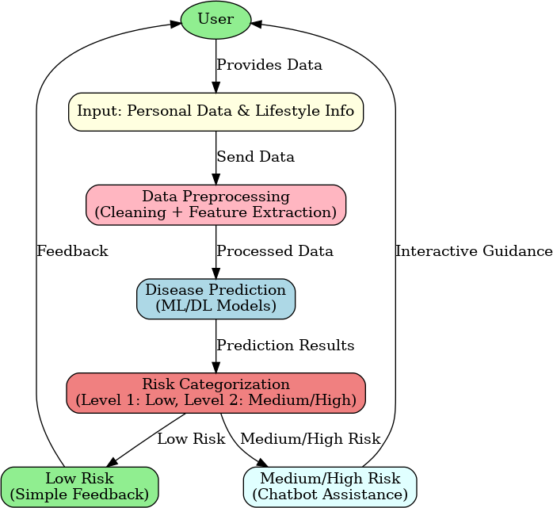

**Fig 2.1 Data Flow Diagram**

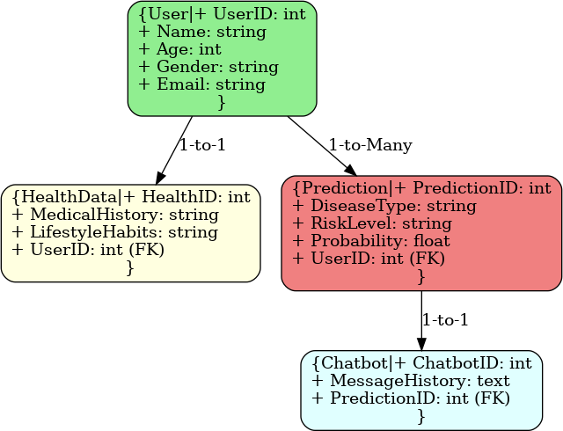

**Fig 2.2 Entity Relationship Diagram**

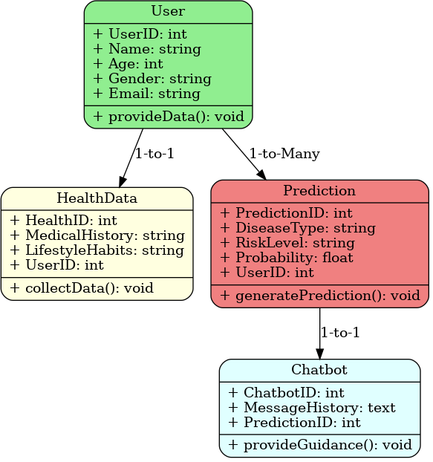

**Fig 2.3 UML Diagram**

* + 1. **PERFORMANCE REQUIREMENTS**
* Accuracy:
  + The prediction models should achieve an accuracy of at least 90% for the classification of disease risks.
  + Specificity and sensitivity should be optimized to reduce false positives and false negatives.
* Response Time:
  + The system should provide initial health risk assessments within 5 seconds of user input.
  + For Level 2 (Medium/High Risk) users, the AI-powered chatbot should respond within 2 seconds during interactions.
* Usability:
  + The user interface should be intuitive and easy to navigate, with a maximum of 3 clicks required to access any primary function.
* Availability:
  + The system should have an uptime of 99.9%, with planned maintenance scheduled during off-peak hours.
  + A failover mechanism should be in place to ensure continuity in case of server failure.
* Maintainability:
  + The codebase should be modular and well-documented to facilitate easy updates and bug fixes.
  + The system should support automated testing to ensure reliability with new deployments.

These performance requirements will help ensure that the WeCare system is reliable, efficient, and user-friendly, while maintaining high standards of accuracy and security.

* + 1. **SOFTWARE QUALITY ATTRIBUTES**

Software Quality Attributes, also known as non-functional requirements, define the overall qualities or characteristics of a system that affect its operation and user experience. Here are some key software quality attributes relevant to the WeCare system:

1. Reliability
   * The system should consistently perform its intended functions under specified conditions.
   * It should have high fault tolerance and minimal downtime.
2. Usability
   * The user interface should be intuitive, easy to navigate, and accessible to all users, including those with disabilities.
   * The system should provide helpful error messages and support features.
3. Efficiency
   * The system should make optimal use of resources, including processing power, memory, and network bandwidth.
   * It should have fast response times and handle concurrent users effectively.
4. Scalability
   * The system should accommodate increasing numbers of users and data without significant performance degradation.
   * It should support horizontal and vertical scaling.
5. Portability
   * The system should be deployable on various platforms and environments with minimal changes.
   * It should support cloud-based, on-premises, and hybrid deployments.
6. Performance
   * The system should meet response time requirements and handle large volumes of data efficiently.
   * It should be optimized for speed and resource utilization.
7. Availability
   * The system should be available for use as required, with minimal downtime.
   * It should have failover and redundancy mechanisms to ensure continuous operation.

**CHAPTER-3**

**SYSTEM DESIGN AND DATABASE DESIGN**

* 1. **DECOMPOSITION DESCRIPTION**

1. User Interface (UI)
   * Input Forms: Collects user personal and lifestyle information such as age, gender, medical history, and habits.
   * Display Results: Shows the user's health risk levels and personalized advice.
   * Chatbot Interface: Provides interactive guidance for medium/high-risk users.
2. Data Collection
   * User Data Validation: Ensures that the input data from users is accurate and complete.
3. Data Processing
   * Data Preprocessing: Cleans and preprocesses user data for analysis, handling missing values, normalization, etc.
   * Feature Extraction: Identifies relevant features from the user data that are used for prediction.
4. Machine Learning Models
   * Model Training: Trains machine learning and deep learning models using historical data to predict disease risk.
   * Model Evaluation: Evaluates the performance of the models to ensure high accuracy.
   * Model Deployment: Deploys the trained models for real-time prediction.
5. Risk Prediction
   * Prediction Engine: Applies trained models to new user data to predict the likelihood of each of the six diseases.
   * Risk Categorization: Categorizes the predicted risk levels into Level 1 (Low Risk) and Level 2 (Medium/High Risk).
6. Feedback Generation
   * Simple Feedback: Generates a non-intrusive message for users with low risk.
   * Detailed Guidance: Provides detailed, interactive guidance via the AI-powered chatbot for users at higher risk.
7. System Monitoring and Maintenance
   * Performance Monitoring: Continuously monitors the system's performance and accuracy.
   * Updates and Maintenance: Regularly updates the system and models to incorporate new data and improve performance.
   1. **DEPENDENCY DESCRIPTION**

* User Interface (UI)
  + Depends on: Data Collection and Feedback Generation components.
  + Reason: The UI requires user data to be validated and processed before it can display results or interact with users through the chatbot.
* Data Collection
  + Depends on: User Interface (UI).
  + Reason: It collects and validates user input provided through the UI.
* Data Processing
  + Depends on: Data Collection.
  + Reason: It requires validated user data for preprocessing and feature extraction.
* Machine Learning Models
  + Depends on: Data Processing.
  + Reason: It relies on preprocessed and feature-extracted data to train, evaluate, and deploy models.
* Risk Prediction
  + Depends on: Machine Learning Models and Data Processing.
  + Reason: It applies trained models to preprocessed user data to predict disease risks.
* Risk Categorization
  + Depends on: Risk Prediction.
  + Reason: It categorizes the predicted risk levels into low, medium, or high risk based on the output from the prediction models.
* Feedback Generation
  + Depends on: Risk Categorization.
  + Reason: It generates personalized advice and guidance based on the categorized risk levels.
* Security and Privacy
  + Depends on: All components, especially Data Collection, Data Processing, and User Interface.
  + Reason: It ensures data encryption and compliance with regulations at every stage where user data is handled.
* System Monitoring and Maintenance
  + Depends on: All operational components.
  + Reason: It monitors the performance, reliability, and security of the entire system and ensures updates and maintenance are applied as needed.
  1. **DETAILED DESIGN**

1. User Interface (UI)

* Components:
  + Input Forms: Collect user data such as age, gender, medical history, and habits.
    - Design: Easy-to-use forms with validation checks.
  + Results Display: Show health risk levels and personalized advice.
    - Design: Clear visual representation with color-coded risk levels.
  + Chatbot Interface: Interactive guidance for higher-risk users.
    - Design: Conversational UI with quick response buttons and text input.

1. Data Collection

* Components:
  + Data Validation: Ensure accuracy and completeness of user input.
    - Design: Automated validation scripts to check for missing or inconsistent data.
  + Data Storage: Secure database to store user information.
    - Design: Encrypted relational database (e.g., MySQL or PostgreSQL).

1. Data Processing

* Components:
  + Preprocessing Module: Clean and normalize user data.
    - Design: Implement data cleaning techniques like handling missing values and normalization.
  + Feature Extraction Module: Identify relevant features for prediction.
    - Design: Algorithms to extract features like age, lifestyle habits, and medical history.

1. Machine Learning Models

* Components:
  + Model Training: Train models on historical data.
    - Design: Use algorithms like decision trees, random forests, and neural networks.
  + Model Evaluation: Evaluate models for accuracy, sensitivity, and specificity.
    - Design: Cross-validation techniques and performance metrics

1. Risk Prediction

* Components:
  + Prediction Engine: Apply trained models to new user data.
    - Design: RESTful API for real-time predictions.
  + Risk Categorization: Categorize risk levels into low, medium, or high.
    - Design: Threshold-based classification to determine risk levels.

1. Feedback Generation

* Components:
  + Simple Feedback Module: Generate non-intrusive messages for low-risk users.
    - Design: Predefined templates with personalized content.
  + Detailed Guidance Module: Provide interactive guidance for higher-risk users via chatbot.
    - Design: AI-powered responses with educational content and actionable advice.

1. Security and Privacy

* Components:
  + Data Encryption: Encrypt data at rest and in transit.
    - Design: Use AES-256 for data encryption.
  + Compliance Module: Ensure compliance with regulations (e.g., GDPR, HIPAA).
    - Design: Regular audits and adherence to data protection standards.

1. System Monitoring and Maintenance

* Components:
  + Performance Monitoring: Track system performance and accuracy.
    - Design: Implement monitoring tools like Prometheus and Grafana.
  + Automated Testing: Regular testing of system components.
    - Design: Use automated testing frameworks for continuous integration and deployment

1. Interoperability

* Components:
  + API Integration: Integrate with external systems like EHRs.
    - Design: Develop and expose secure APIs for data exchange.
  + Data Exchange: Support various data formats (e.g., JSON, XML).
    - Design: Implement data parsers and converters.
  1. **PROPOSED SAMPLING METHODS**

For the WeCare system, the choice of sampling method depends on the characteristics of the data collected and the objectives of the machine learning (ML) and deep learning (DL) models. Since the system focuses on predicting six different diseases with varying risk levels, the following sampling strategies are likely used:

1. Stratified Sampling

* Why Used in WeCare:
  + Ensures proportional representation of all disease types (e.g., liver disease, pneumonia, etc.) and risk levels (low, medium, high).
  + Balances the dataset across demographic categories like age, gender, or geographic location.
* Example in WeCare:
  + Dividing the dataset into strata based on disease types and ensuring each stratum contributes proportionally to the training dataset.

1. Oversampling (e.g., SMOTE)

* Why Used in WeCare:
  + Addresses class imbalance issues, such as a smaller number of high-risk cases compared to low-risk ones.
  + Improves model sensitivity for underrepresented risk categories.
* Example in WeCare:
  + If the number of high-risk cases for stroke is significantly smaller, synthetic samples are generated to balance the dataset.

1. Weighted Sampling

* Why Used in WeCare:
  + Focuses on prioritizing rare but critical cases (e.g., high-risk users with severe symptoms).
  + Ensures the model pays more attention to minority classes without oversampling.
* Example in WeCare:
  + Assigning higher weights to high-risk predictions during training to improve accuracy in these cases.

1. Combination Sampling

* Why Used in WeCare:
  + To balance the need for diversity and fair representation with the focus on critical risk categories.
* Example in WeCare:
  + First, stratify the dataset by disease type and risk levels, and then apply oversampling or weighted sampling within underrepresented strata.

### Real-World Application in WeCare

Given WeCare’s dual-level prediction system:

### For Level 1 (Low Risk):

* + Stratified Sampling ensures adequate representation of low-risk cases, preventing bias toward any specific disease.

### For Level 2 (Medium/High Risk):

* + Oversampling and Weighted Sampling are used to train models effectively for medium/high-risk cases, ensuring accurate and actionable predictions.

These methods ensure the WeCare system achieves high accuracy while addressing imbalances in real-world healthcare data.

* 1. **DATABASE DESIGN**
     1. **DIABETICS DATABASE**

PredictionData Table

* + - * Stores the input parameters from the form, associated with each prediction request.
      * Columns:
        + PredictionID (Primary Key): Unique identifier for each prediction record.
        + UserID (Foreign Key): Links the record to the user in the Users table.
        + Pregnancies: Number of times the user has been pregnant.
        + Glucose: Glucose level.
        + BloodPressure: Blood pressure measurement.
        + SkinThickness: Triceps skin fold thickness.
        + Insulin: 2-Hour serum insulin.
        + BMI: Body mass index.
        + DiabetesPedigreeFunction: Genetic predisposition score.
        + Age: Age of the user.
        + PredictionDate: Date when the prediction was made.
      * INSERT INTO PredictionData (UserID, Pregnancies, Glucose, BloodPressure, SkinThickness, Insulin, BMI, DiabetesPedigreeFunction, Age, PredictionDate)

VALUES (1, 2, 150, 80, 25, 140, 32.5, 0.671, 28, NOW());

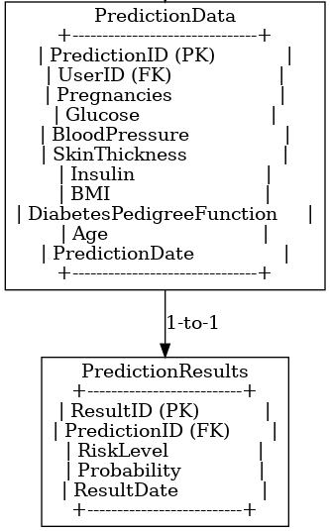

**Fig3.1 Diabetics Database Design**

* + 1. **HEART DISEASE DATABASE**

PredictionData Table

* + - * Purpose: Stores the input parameters for each prediction request.
      * Columns:
        + PredictionID (Primary Key): Unique identifier for each prediction.
        + UserID (Foreign Key): Links the record to a user.
        + Age: Age of the user.
        + Gender: Gender (1: Male, 0: Female).
        + ChestPainType: Type of chest pain (0-3 values).
        + RestingBP: Resting blood pressure (in mm Hg).
        + Cholesterol: Serum cholesterol (in mg/dl).
        + FastingBloodSugar: Fasting blood sugar > 120 mg/dl (1: Yes, 0: No).
        + RestECG: Resting electrocardiographic result (0-2 values).
        + MaxHeartRate: Maximum heart rate achieved.
        + ExerciseInducedAngina: Exercise-induced angina (1: Yes, 0: No).
        + Oldpeak: ST depression induced by exercise relative to rest.
        + Slope: The slope of the peak exercise ST segment (0-2 values).
        + PredictionDate: Date of prediction request
      * INSERT INTO PredictionData (UserID, Age, Gender, ChestPainType, RestingBP, Cholesterol, FastingBloodSugar, RestECG, MaxHeartRate, ExerciseInducedAngina, Oldpeak, Slope, PredictionDate)

VALUES (1, 45, 1, 2, 130, 250, 0, 1, 150, 0, 2.3, 1, NOW());

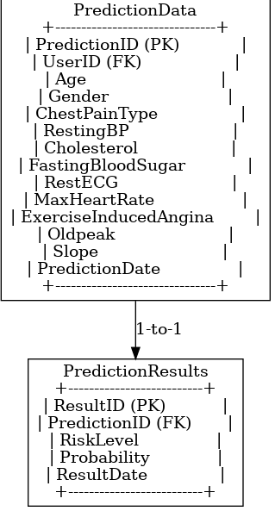

**Fig3.2 Heart Disease Database Design**

* + 1. **KIDNEY DISEASE DATABASE**

PredictionData Table

* + - * Purpose: Stores input parameters for each kidney disease prediction.
      * Columns:
        + PredictionID (Primary Key): Unique identifier for each prediction.
        + UserID (Foreign Key): Links to the Users table.
        + Age: Age of the user.
        + BloodPressure: Blood pressure reading.
        + SpecificGravity: Specific gravity measurement.
        + BloodGlucoseRandom: Blood glucose random value.
        + BloodUrea: Blood urea value.
        + SerumCreatinine: Serum creatinine level.
        + Hemoglobin: Hemoglobin level.
        + PusCellClumps: Presence of pus cell clumps (0: Not Present, 1: Present).
        + Bacteria: Presence of bacteria (0: Not Present, 1: Present).
        + Hypertension: Hypertension status (0: No, 1: Yes).
        + DiabetesMellitus: Diabetes Mellitus status (0: No, 1: Yes).
        + CoronaryArteryDisease: Coronary Artery Disease status (0: No, 1: Yes).
        + Appetite: Appetite condition (0: Good, 1: Poor).
        + PedalEdema: Presence of pedal edema (0: No, 1: Yes).
        + Anemia: Presence of anemia (0: No, 1: Yes).
        + PredictionDate: Date of the prediction request
      * INSERT INTO KidneyPredictionData (

UserID, Age, BloodPressure, SpecificGravity, BloodGlucoseRandom, BloodUrea, SerumCreatinine, Hemoglobin, PusCellClumps, Bacteria, Hypertension, DiabetesMellitus, CoronaryArteryDisease, Appetite, PedalEdema, Anemia, PredictionDate

)

VALUES (

1, 45, 120, 1.015, 110,

45, 1.2, 13.5, 0, 0,

1, 1, 0, 0,

0, 0, NOW()

);

* + 1. **LIVER DISEASE DATABASE**

PredictionData Table

* + - * Purpose: Stores input parameters for each kidney disease prediction.
      * Columns:
        + age: The patient's age (Integer).
        + total_bilirubin: Total bilirubin level (Float).
        + direct_bilirubin: Direct bilirubin level (Float).
        + alkaline_phosphotase: Alkaline Phosphatase level (Float).
        + alamine_aminotransferase: Alamine Aminotransferase level (Float).
        + aspartate_aminotransferase: Aspartate Aminotransferase level (Float).
        + total_proteins: Total proteins in the blood (Float).
        + albumin: Albumin level in the blood (Float).
        + albumin_and_globulin_ratio: Ratio of albumin to globulin in the blood (Float).
        + gender: Gender of the patient (Enum type with 'male' and 'female')
* INSERT INTO Liver_Disease_Patient_Data (age, total_bilirubin, direct_bilirubin, alamine_aminotransferase, aspartate_aminotransferase, total_proteins, albumin, albumin_and_globulin_ratio, gender)VALUES ( 45, 1.2, 0.4, 130, 35, 40, 6.5, 3.8, 1.1, 'male');
  + 1. **STROKE DISEASE DATABASE**

PredictionData Table

* + - * Purpose:This table stores input parameters for each stroke disease prediction.
      * Columns:
        + age: The patient's age (Integer).
        + avg_glucose_level: Average glucose level of the patient (Float).
        + hypertension: Whether the patient has hypertension (Boolean: 1 for yes, 0 for no).
        + heart_disease: Whether the patient has heart disease (Boolean: 1 for yes, 0 for no).
        + gender: Gender of the patient (Enum type with 'male' and 'female').
        + ever_married: Whether the patient has been married or ever married (Boolean: 1 for yes, 0 for no).
        + work_type: Type of work the patient is engaged in (Integer: 0 for Private, 1 for Self-employed, etc.).
        + residence_type: Whether the patient lives in an urban or rural area (Boolean: 1 for Urban, 0 for Rural).
        + smoking_status: Smoking status of the patient (Integer: 0 for never smoked, 1 for sometimes, 2 for formerly smoked, 3 for smokes).
* INSERT INTO Stroke_Disease_Prediction_Data (

age, avg_glucose_level, hypertension, heart_disease, gender, ever_married, work_type, residence_type, smoking_status

)

VALUES (

55, 105.5, 1, 0, 'male', 1, 0, 1, 3

);

**CHAPTER-4**

**IMPLEMENTATION AND RESULT**

* 1. **IMPLEMENTATION**

The **WeCare system** is designed to provide users with a comprehensive, user-friendly platform that assesses health risks for six common diseases: liver disease, pneumonia, kidney disease, diabetes, stroke, and heart disease. The system uses machine learning (ML) and deep learning (DL) algorithms to analyze user inputs and predict disease risk. The predictions are categorized into two levels, offering tailored advice and guidance based on the user's risk level.

### Model Development

**Machine Learning Models**: The system employs various ML techniques to predict disease risk. The algorithms used may include:

* + Logistic Regression
  + Random Forests
  + Support Vector Machines (SVM)
  + Gradient Boosting Machines (GBM)

**Deep Learning Models**: To improve prediction accuracy, deep learning methods such as Artificial Neural Networks (ANN) or Convolutional Neural Networks (CNN) may be employed, especially for handling complex and large datasets.

### Prediction and Categorization

Once the model is trained, it can be used to predict the likelihood of the user having one of the six diseases. The prediction is categorized into two levels:

* + **Level 1 (Low Risk)**: Users whose disease likelihood is below a certain threshold receive a simple message. This message could be something like:
    - "Your risk of [disease] is low. Keep maintaining a healthy lifestyle."
  + **Level 2 (Medium/High Risk)**: Users with a higher risk level are provided with more detailed, interactive feedback. In addition to the basic risk prediction, the system will offer:
* **AI-powered Chatbot**: Users at medium or high risk will interact with a chatbot that provides personalized advice, potential next steps, and guidance on lifestyle changes, medical consultations, or further tests.
  1. **RESULT**
     1. **HOME PAGE**

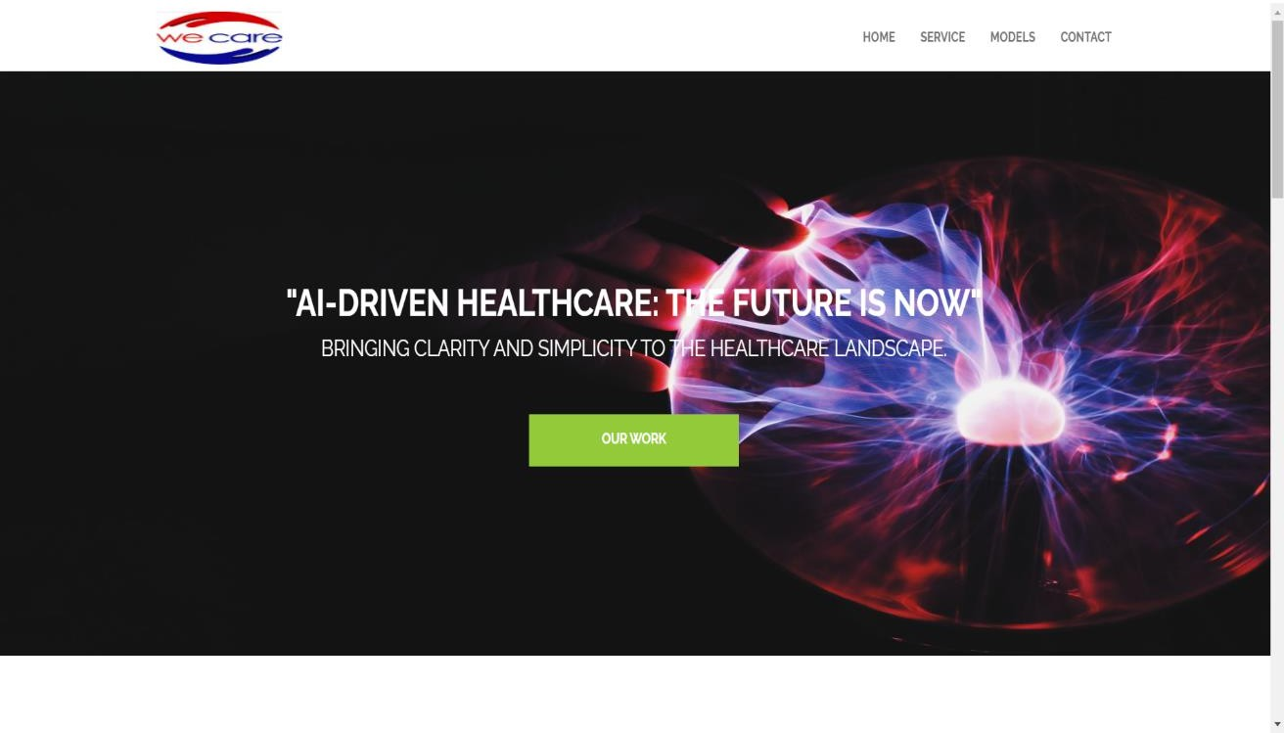

* + 1. **OUR MODEL PAGE**

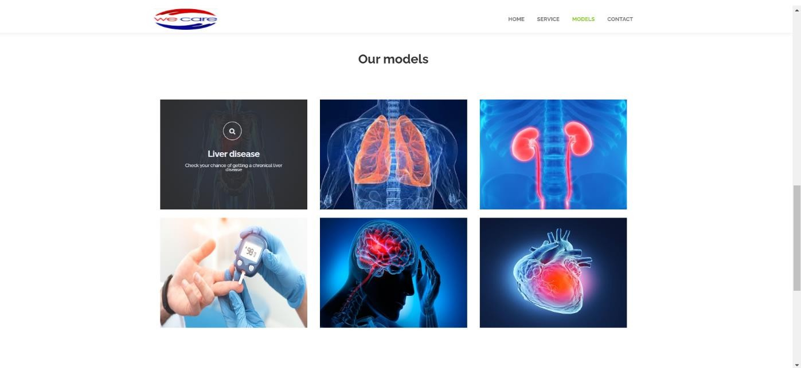

* + 1. **CONTACT PAGE**

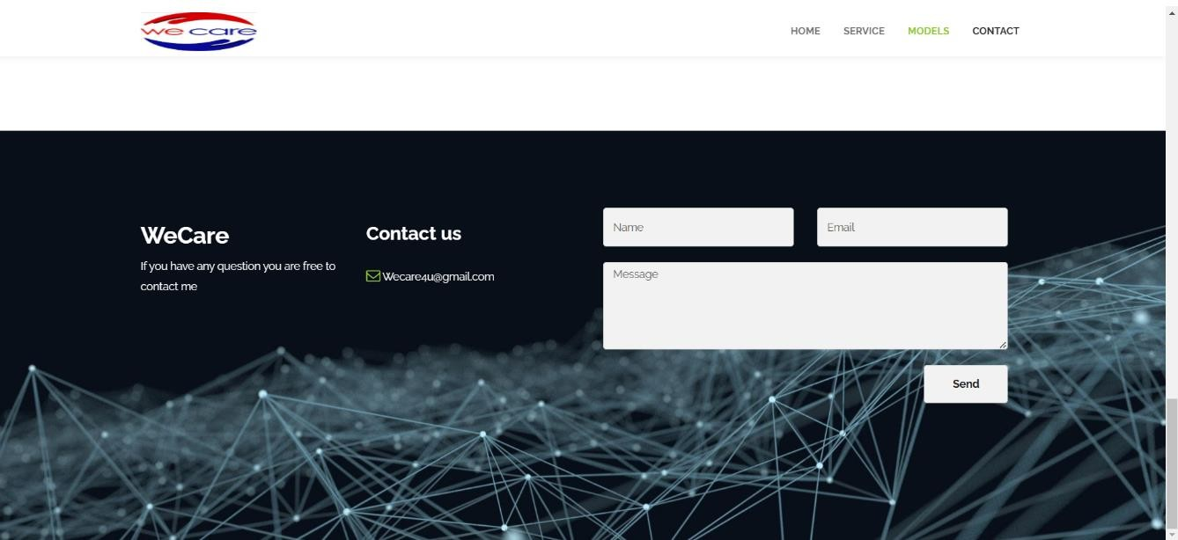

* + 1. **FORM INPUT PAGE**

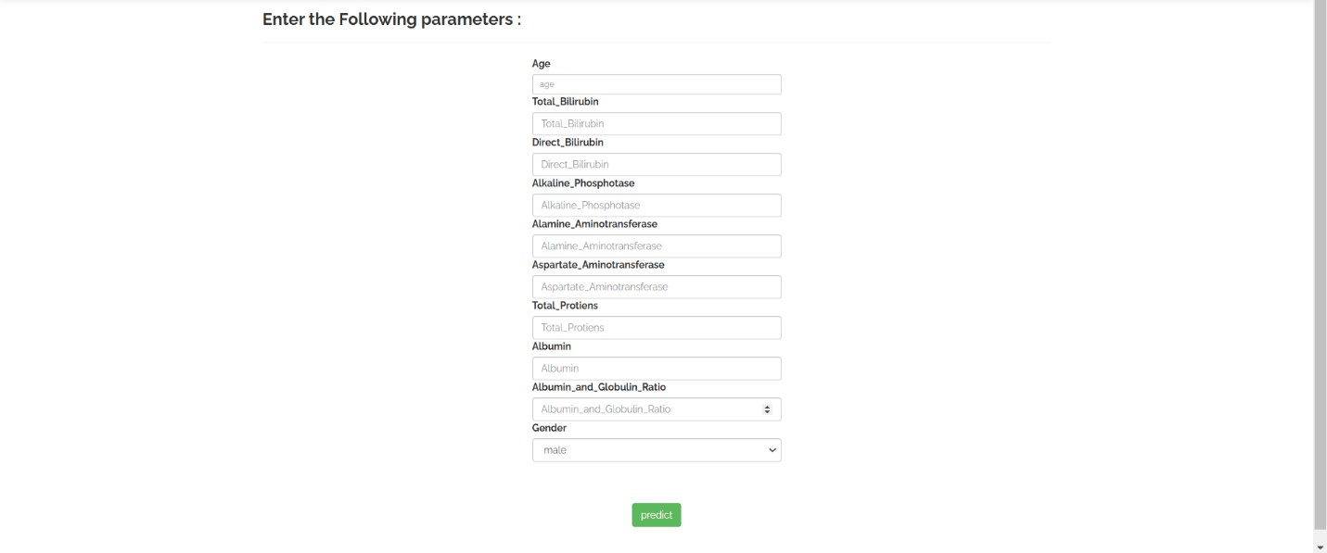

* + 1. **LEVEL 1 PREDICTION PAGE**

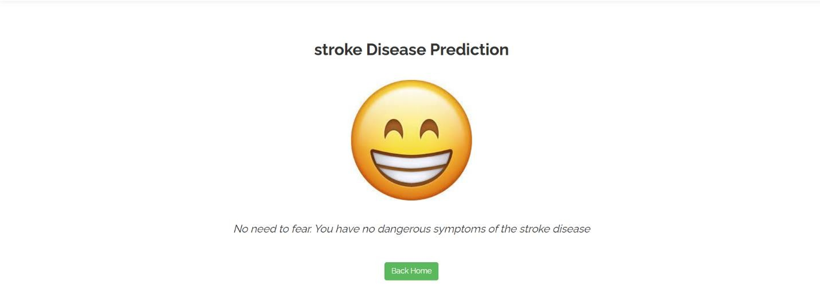

* + 1. **LEVEL 2 PREDICTION PAGE**

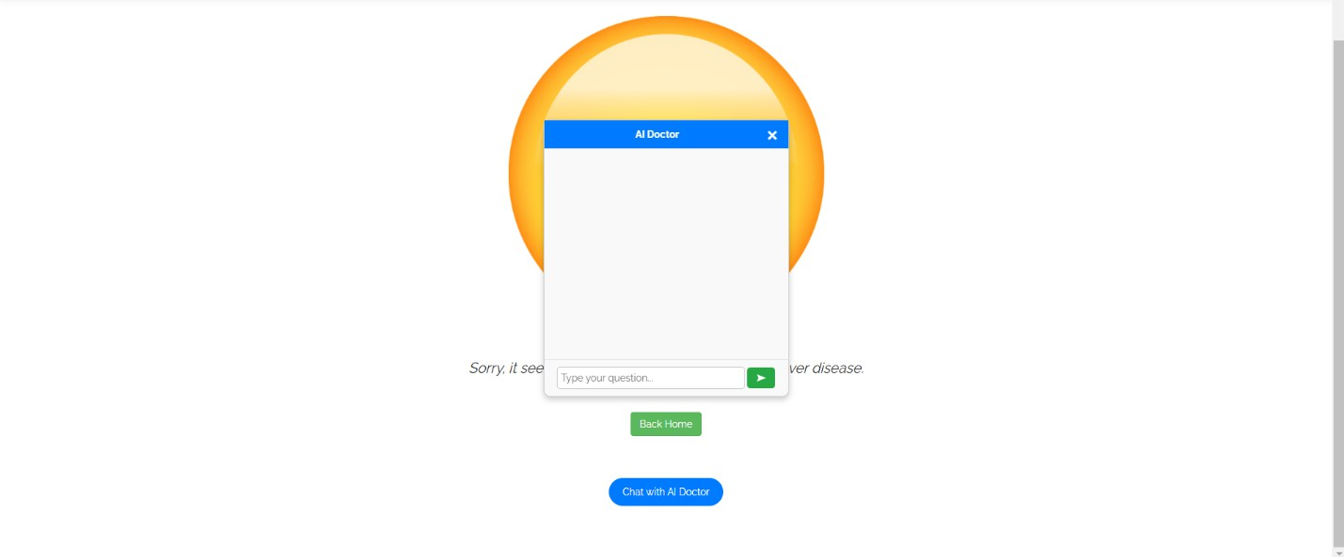

**CHAPTER -5**

**CONCLUSION AND FUTURE WORK**

* 1. **SUMMARY**

The WeCare application is a health risk assessment platform that utilizes machine learning and deep learning algorithms to predict the likelihood of users developing six common diseases: liver disease, pneumonia, kidney disease, diabetes, stroke, and heart disease. Designed to be user-friendly and accessible, the system provides tailored predictions and advice to empower users in managing their health effectively.

Key features of the application include:

* + 1. Disease Risk Prediction:
       - Employs advanced ML/DL models to analyze user data (age, gender, lifestyle, and medical history) and predict disease risk accurately.
    2. Risk Categorization:
       - Level 1 (Low Risk): Offers a simple, non-intrusive message encouraging users to maintain a healthy lifestyle.
       - Level 2 (Medium/High Risk): Provides detailed, personalized guidance via an AI-powered chatbot with actionable health advice.
    3. Interactive Chatbot:
       - Assists high-risk users by answering questions, offering recommendations, and guiding next steps like medical consultations or lifestyle adjustments.
    4. User-Friendly Interface:
       - Intuitive design for easy data input, clear risk predictions, and seamless interaction with the chatbot.
    5. Backend and Security:
       - Powered by scalable cloud architecture with secure data storage and encrypted communication to ensure user privacy.
  1. **FUTURE WORK**
     1. Expansion of Disease Categories
* Incorporate risk assessment for additional diseases or health conditions, such as mental health disorders, cancer, or autoimmune diseases.
* Introduce specialized modules for pediatric and geriatric populations to address age-specific health concerns.
  + 1. Personalized Wellness Plans
* Provide comprehensive, personalized wellness plans, including exercise routines, dietary recommendations, and mental health tips tailored to the user’s health risk profile.
* Offer dynamic updates to wellness plans based on user progress or new data inputs.
  + 1. Advanced AI-Powered Chatbot
* Upgrade the chatbot to include voice recognition and natural language understanding for more intuitive interactions.
* Expand the chatbot's capabilities to handle complex medical queries and provide more detailed responses based on user-specific data.
  + 1. Health Community and Peer Support
* Create a community platform where users can share experiences, success stories, and advice to foster mutual support and motivation.
  + 1. Multilingual and Cultural Adaptations
* Support multiple languages and culturally relevant content to make the application accessible globally.
  + 1. Integration with National and Global Health Systems
* Collaborate with public health organizations to offer health awareness campaigns and screenings.
* Use aggregated data (with privacy safeguards) to support epidemiological studies and public health planning.

**REFERENCES**

Machine Learning in Healthcare:

* *Topol, E. J. (2019). High-performance medicine: the convergence of human and artificial intelligence.* Nature Medicine, 25(1), 44-56. https://doi.org/10.1038/s41591- 018-0300-7
* Review of how AI and ML are transforming diagnostics and personalized medicine. Deep Learning for Health Predictions:
* *Miotto, R., Wang, F., Wang, S., Jiang, X., & Dudley, J. T. (2018). Deep learning for healthcare: review, opportunities, and challenges.* Briefings in Bioinformatics, 19(6), 1236-1246. https://doi.org/10.1093/bib/bbx044
* Discussion of deep learning applications in health data analysis. Health Chatbots:
* *Miner, A. S., Milstein, A., & Hancock, J. T. (2017). Talking to machines about personal mental health: Design and ethical considerations.* NPJ Digital Medicine, 1(1), 1-6. https://doi.org/10.1038/s41746-017-0048-y
* Analysis of chatbots in healthcare and their ethical implications. Lifestyle and Disease Prediction:
* *Stewart, J., & Wild, C. P. (2017). Lifestyle risk factors as determinants of health outcomes.* Annual Review of Public Health, 38, 145-156. https://doi.org/10.1146/annurev-publhealth-032315-021418
* Explores the role of lifestyle data in disease risk assessment.